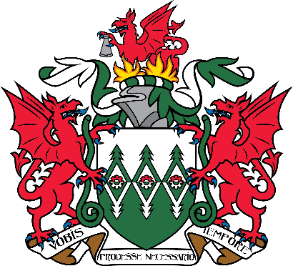

**MID AND WEST WALES FIRE AND RESCUE AUTHORITY**

**Statement of Accounts for the Financial Year 2020/21**

Notice is Hereby Given that pursuant to Section 29 of The Public Audit (Wales) Act 2004 and Section 13 of the Accounts and Audit (Wales) (Amendment) Regulations 2018:

The audit of the Statement of Accounts of Mid and West Wales Fire and Rescue Authority for the year ended 31 March 2021 has been concluded.

The Statement of Accounts, including the Auditor’s report, is available for inspection online.

It is also available at the undermentioned offices for inspection by any local government elector for the area to which the accounts relate, and any such elector may make copies or extracts there from.

Due to Covid-19 restrictions, please contact the Head of Finance to make an appointment.

* + Email: [finance@mawwfire.gov.uk](mailto:finance@mawwfire.gov.uk),
  + Telephone: 01267 226870
  + Post: Fire Service Headquarters, Carmarthen SA31 1SP

Dated: 29th July 2021